Logo

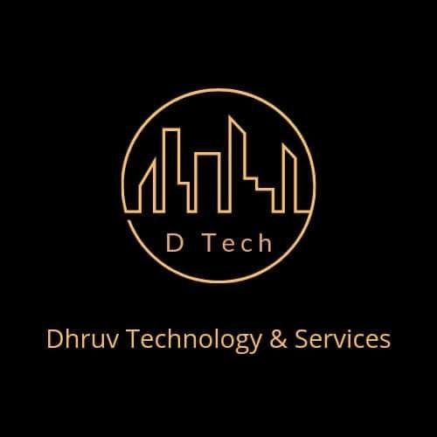

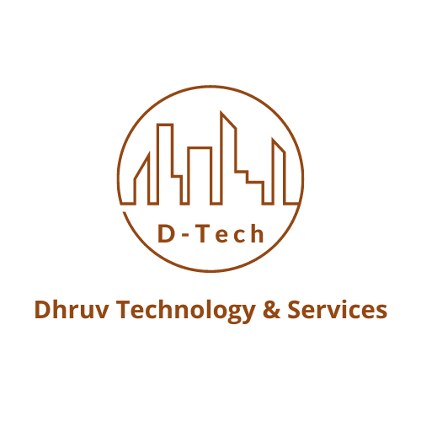

About us

We are a team of work enthusiasts to provide ultimate customer satisfaction in Surveying and Technology by providing the best offers, deals, and after-sales services. Our higher management is experienced with well over 10 years in the same industry with connections and resources with almost every manufacturer and service provider for surveying instruments in India. We provide Surveying instruments of all sorts and brands to every nook and corner of the county. Our services as calibration and repairs of surveying instruments at our fully equipped service station are done by very experienced personnel and we also provide spot calibration and repair services on demand pan India. We are entrusted with many prestigious organizations for their annual maintenance and repairs with customer-oriented exclusive contracts. We also provide preventive maintenance visits to our AMC and CAMC contract-holder clients. We are providing land survey and DPR (Detailed Project Report) services to many prestigious companies around the country. We have a 24*7 working team equipped with the best knowledge, and experience in any type of equipment in the survey and repairs service field.

Our Services

1. Land Surveying

We are experienced with well over 10 years in the Surveying field and we are a team of work enthusiasts to provide ultimate customer satisfaction, providing services across India. We specialize in construction layouts, grid marking, topographical surveys, boundaries, demarcation, subdivision design, title and boundary surveys, unit surveys, digitizing, map reproduction, and preparation, and provide dedicated mapping services. Integrating our newly refined data communications network, high-quality surveying instruments, and experienced staff, our land survey services can be an efficient solution to every project.

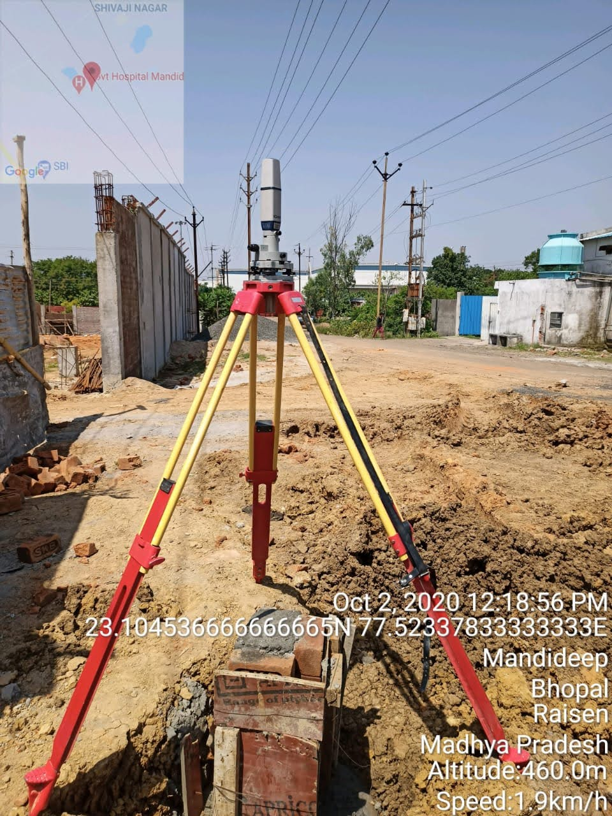

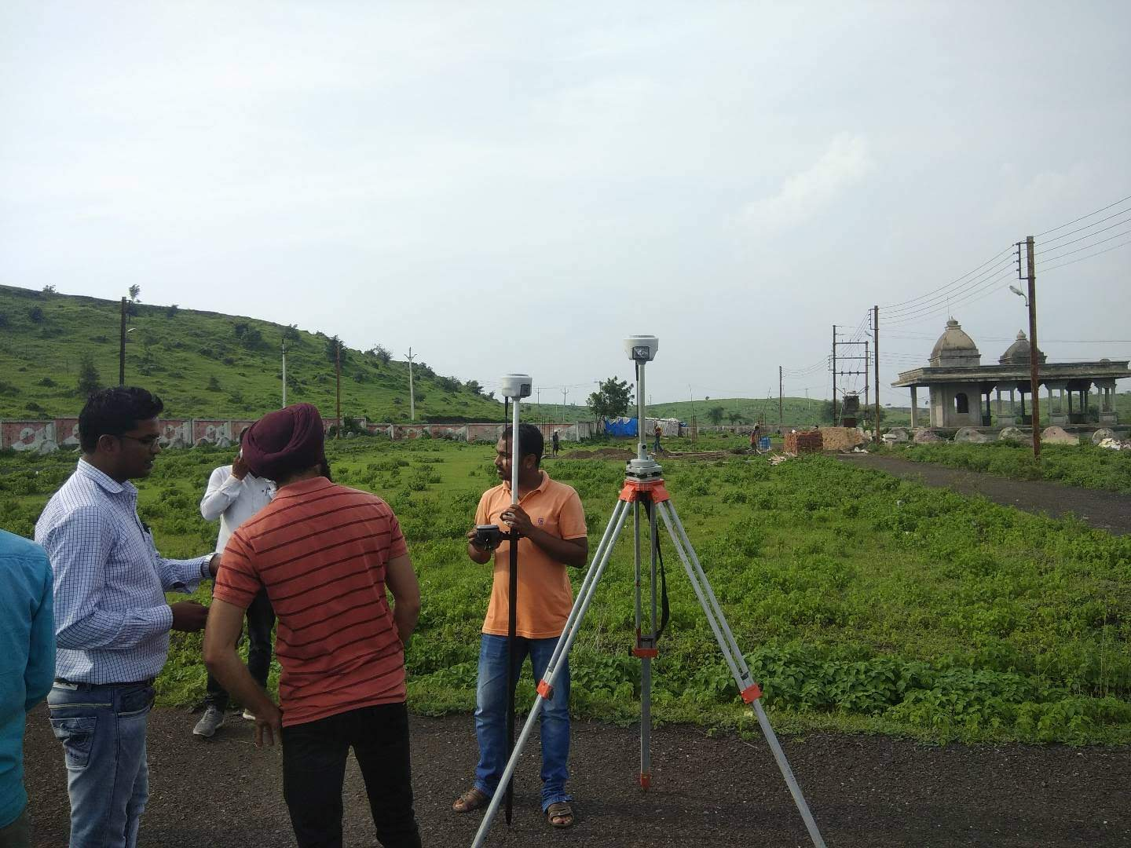

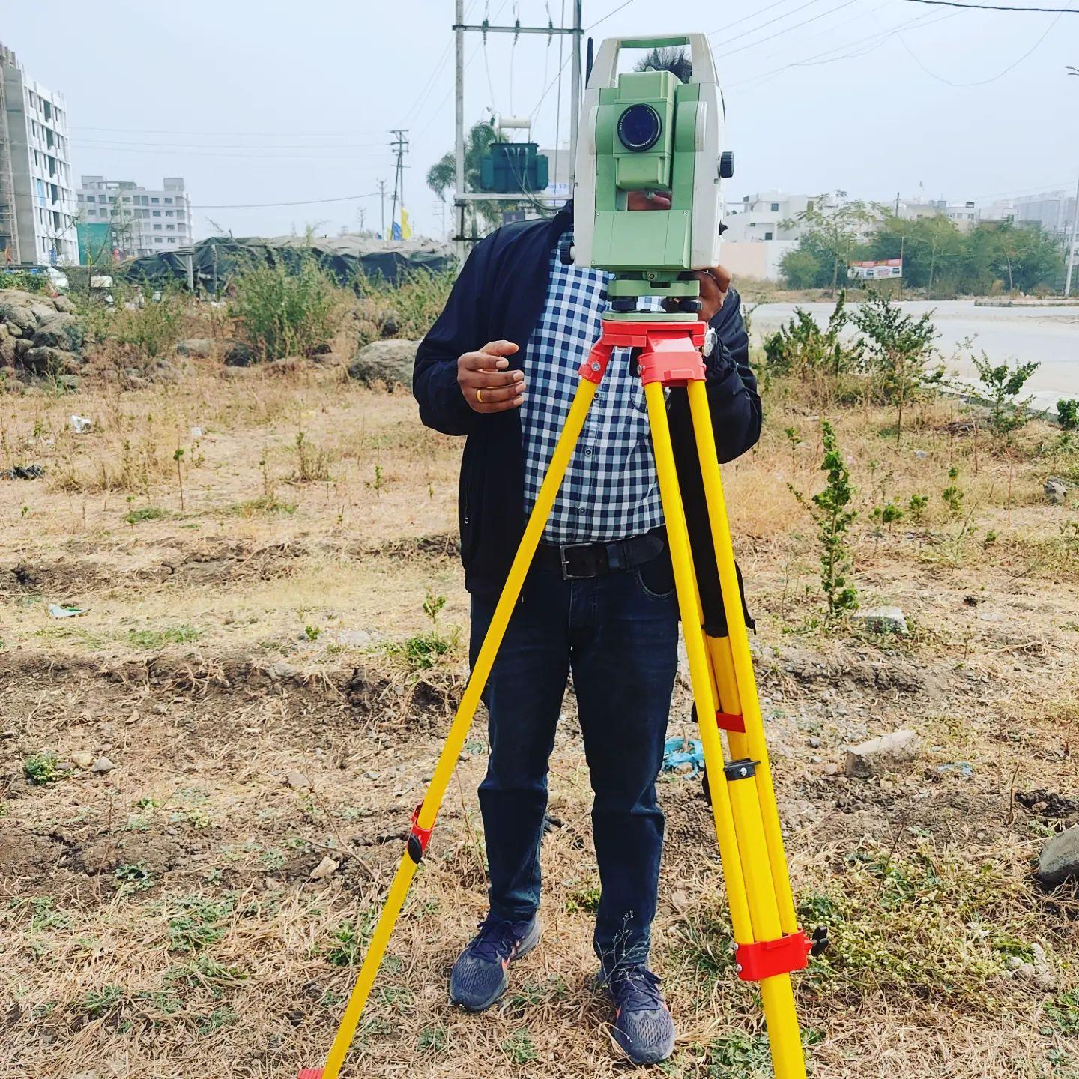

1. Repair and Calibration

Dhruv Technology and Services has a fully equipped service center and experienced staff to calibrate and repair all kinds of Surveying instruments being practiced in India. We Repair, Calibrate, and Provide After-Sale Service to all Civil Surveying Instruments. Our Service Centre is fully equipped with modern technology and the latest test equipment which is required as per Equipment Manufacturer guidelines. We have modern tools and fixtures to Repair and Calibrate Manual and Robotic (Motorised or Motor Driven) Total Stations, DGPS/RTK, Electronic Theodolites, Digital Theodolites, Auto levels, and other Surveying Equipment in India. We have a technically qualified and experienced team of engineers to provide prompt and efficient satisfactory service.

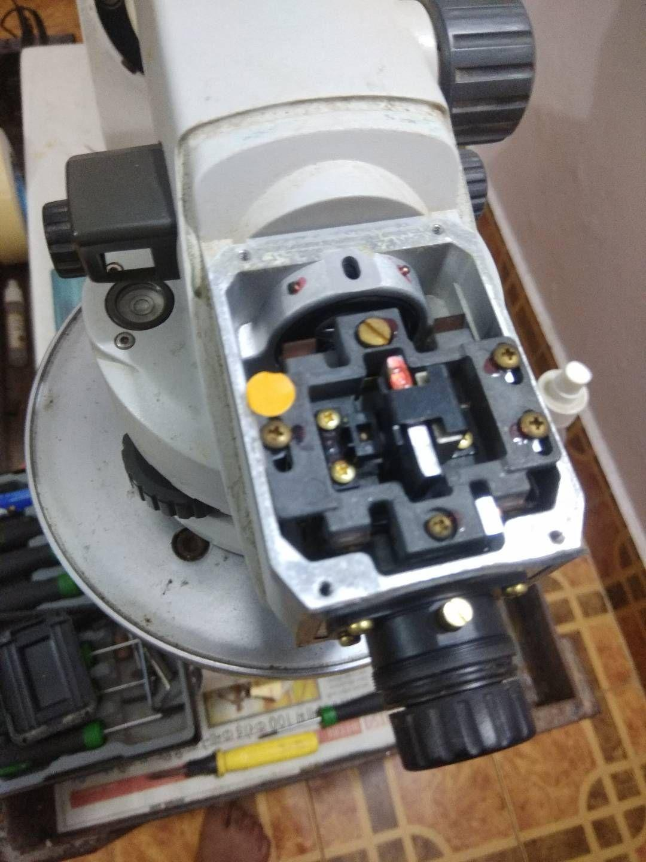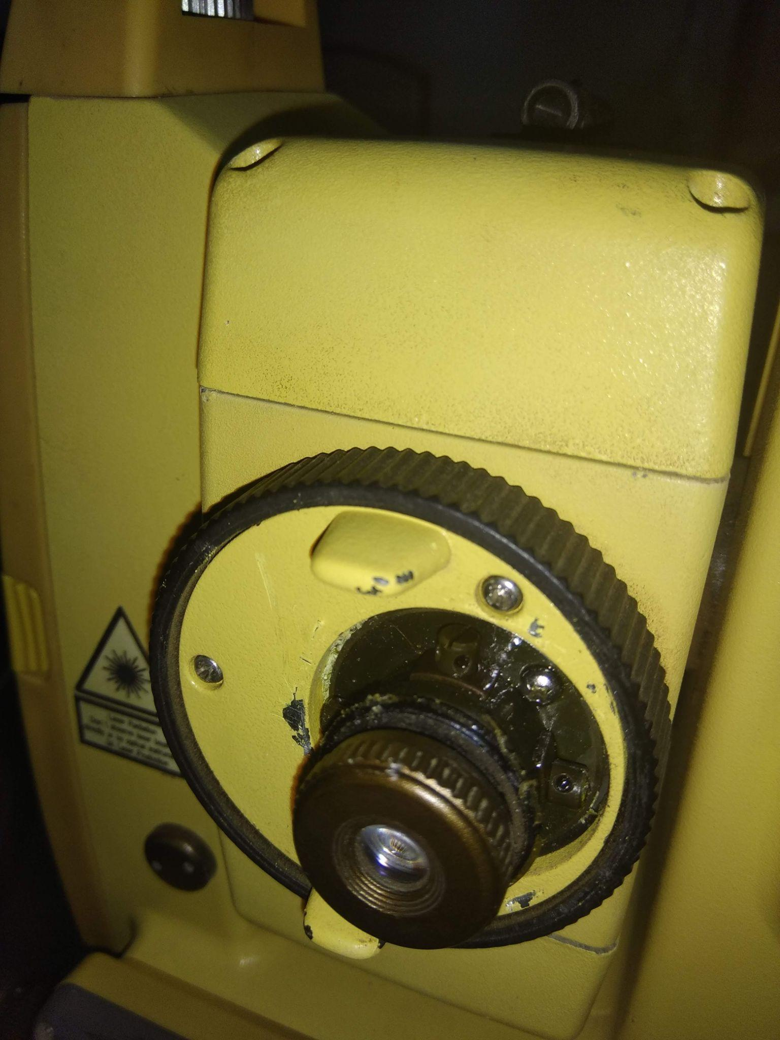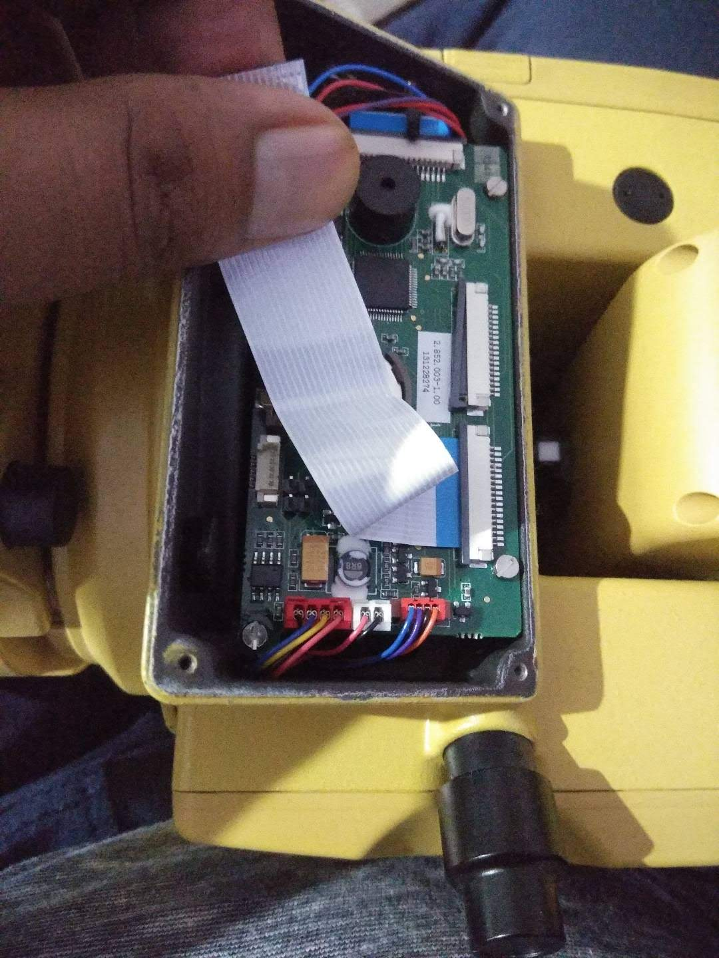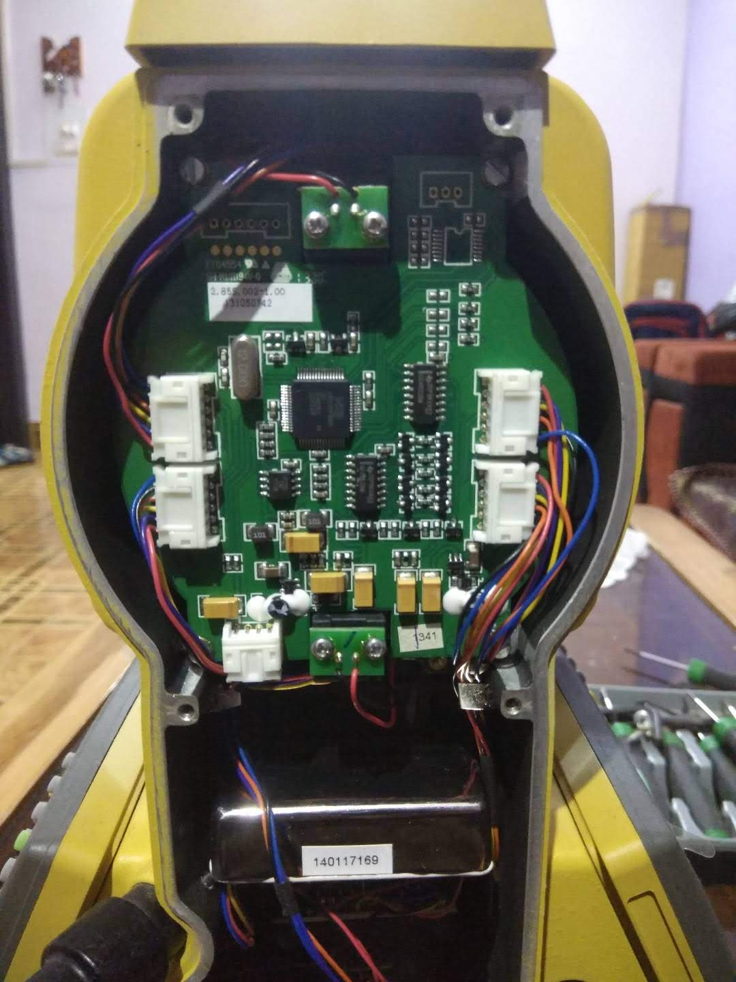

1. Project Report and Consulting

We at Dhruv Technology and Services provide various project reports and cost estimates for our customers in the private as well as government sectors. Our focus is to provide true data and satisfactory conclusions of the reports provided to the client with the help of the latest technology and consulting. We also provide innovative ideas and insight as per customer needs for better understanding and resolution of the project at hand.

1. Testing and Certification

We provide testing and certification for various civil equipment. We are also in league with very prestigious certification institutions which are accredited by India’s most prominent testing and certification authorities such as NABL, etc. We are entrusted by many infrastructures and development companies for our services.

1. Training and Workshops

We are a company which provides Land Survey and civil equipment training in India, land surveying is a process that is used to determine the features and boundaries of a property and to determine easements, and encroachments, to find out how to develop or build on the land, as well as to maintain local codes and regulations. Land Surveyors measure distances, angles, and positions to develop a map of the field.

The objective of this Training is to provide basic knowledge of digital surveying and mapping of the earth's surface using Total Station, DGPS, Auto-Level, and mapping software. The Training starts with an introduction to land surveying followed by fundamentals of surveying instruments and their working & measurements for land surveying and mapping fundamentals, digital surveying techniques, data reduction, etc. After completion of the Course, we will provide certification, and also students will be able to demonstrate standard techniques to locate and determine three-dimensional coordinates of points on the ground using surveying instruments.

1. AMC and CAMC Contracts

We have an exclusive range of AMC (Annual Maintenance Contract) and CAMC (Comprehensive Annual Maintenance Contract) services which are designed according to the needs of our customers. Our customers can choose from our existing offers or redefine a new offer according to their specific needs and mutual understanding.

Our Clients

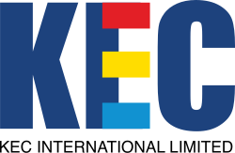

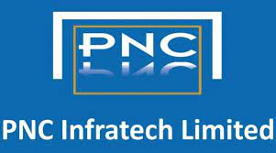







**SOUTH EASTERN COALFIELDS LIMITED**

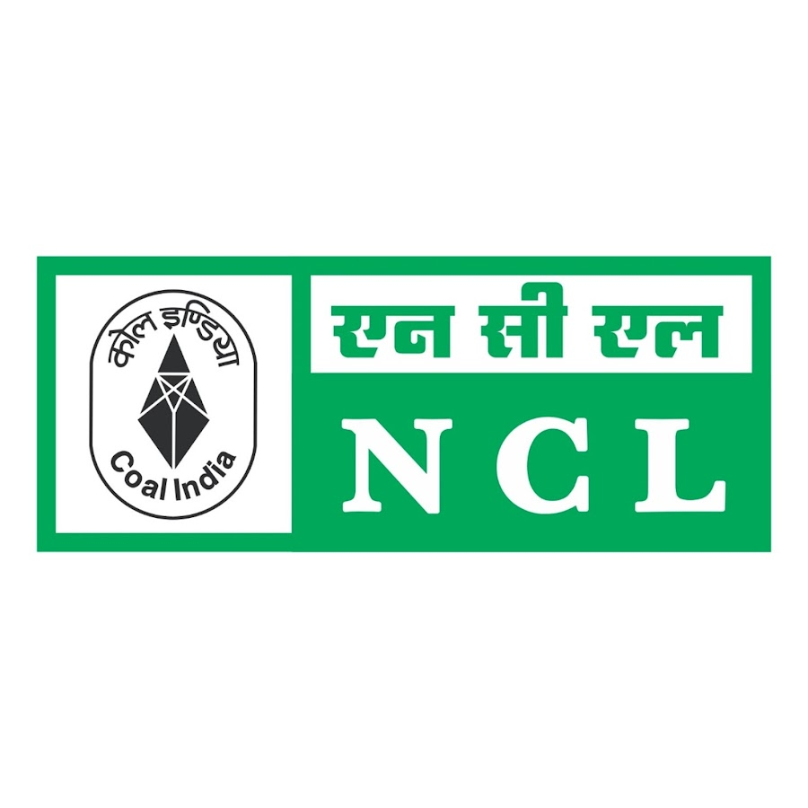

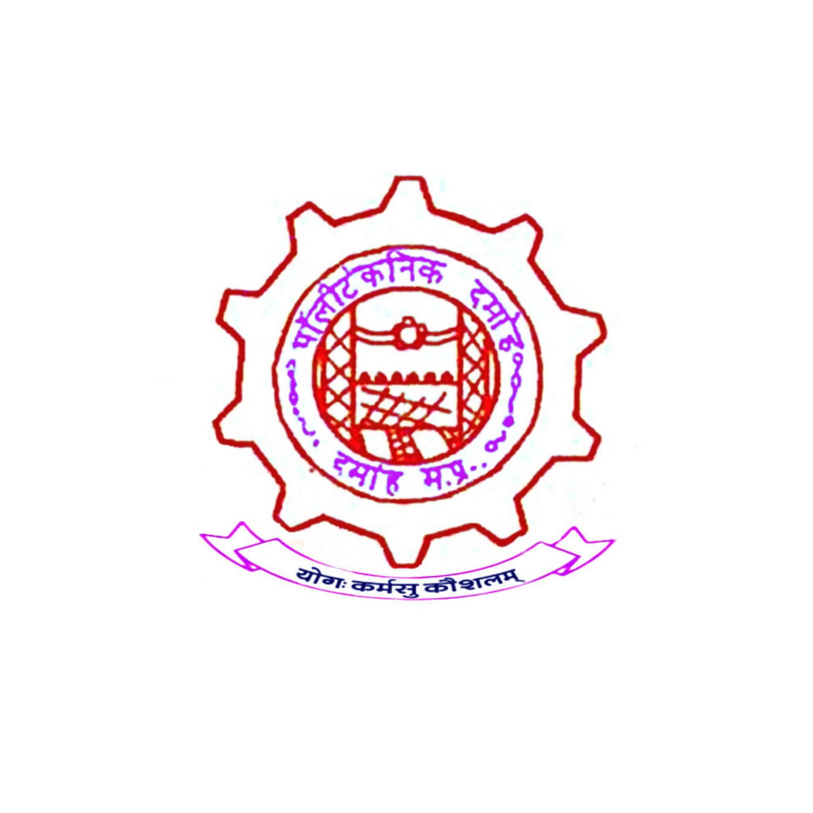

**Government polytechnic College Damoh M.p.**



**Government polytechnic College Satna M.p.**

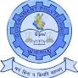

**Government polytechnic College Singrauli M.p.**

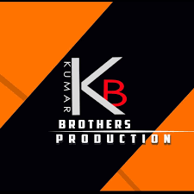

**Kumar Brothers Bhopal**

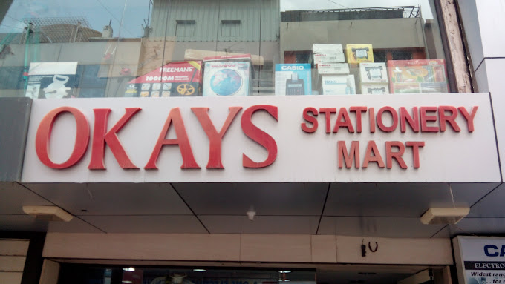

**OKAYS Enterprises**





****P J Coordinates & Associates

**Tavan Infratech Llp**

Oriental University

Private university in Indore, Madhya Pradesh



SNS Consultants

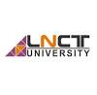LNCT University, Bhopal

University in Bhopal, Madhya Pradesh

Gravity Construction & Consultancy

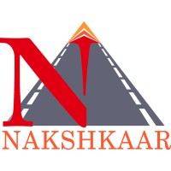Nakshkaar Engineers & Consultants Pvt. Ltd.



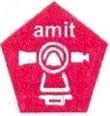Amit Engineering Equipments

United Tools Corporation





Rising Survery & Construction Pvt. Ltd.

**D3_Facebook link :** [**https://www.facebook.com/dtechservices1108?mibextid=ZbWKwL**](https://www.facebook.com/dtechservices1108?mibextid=ZbWKwL)

**D4_Instagram:** [**https://instagram.com/dhruv_technology_and_services?igshid=OTJlNzQ0NWM=**](https://instagram.com/dhruv_technology_and_services?igshid=OTJlNzQ0NWM=)

**D1_LinkedIn:** [**https://www.linkedin.com/company/dhruv-technology-and-services/**](https://www.linkedin.com/company/dhruv-technology-and-services/)

**D2_Youtube:** [**https://www.youtube.com/@dhruvtechnologyservices**](https://www.youtube.com/@dhruvtechnologyservices)

**D5_Google:** [**https://g.co/kgs/PGzNHC**](https://g.co/kgs/PGzNHC)

**USE THIS IMAGE IN About US**

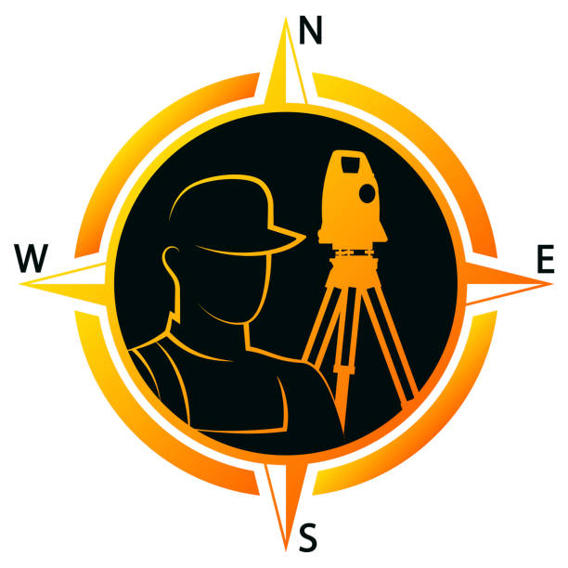

**BRANDS WE DEAL WITH**



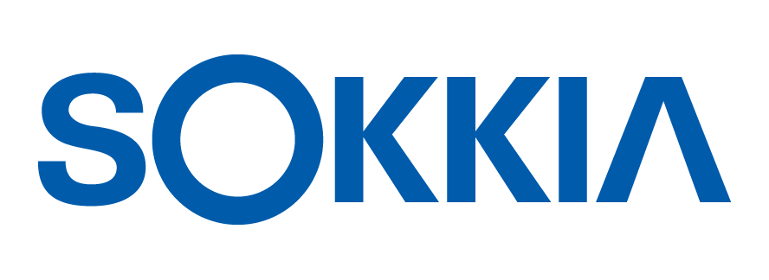















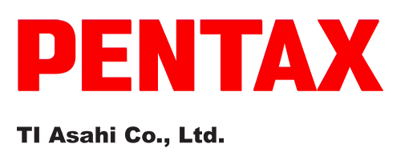



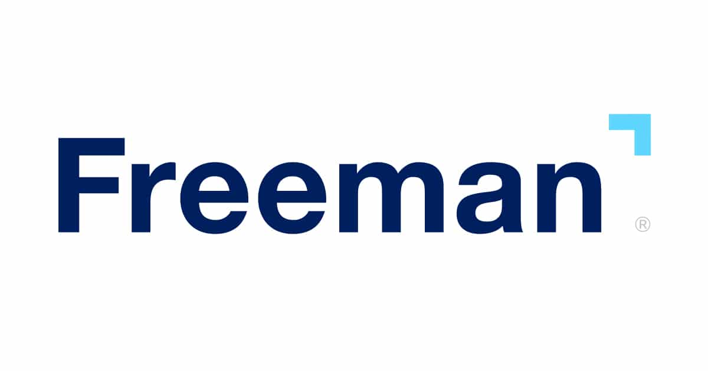





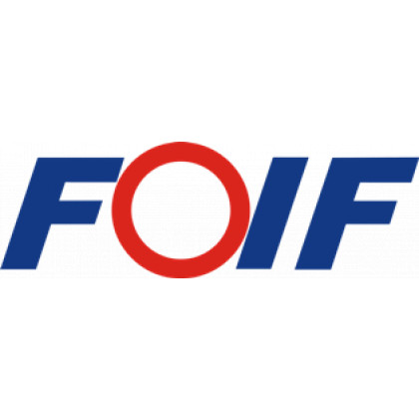





**CHC**

